 | Monday | Tuesday | Wednesday | Thursday | Friday
9.00 – 9.30am | Phonics Session Evidence Me | Phonics Session Evidence Me | Phonics Session Evidence Me | Phonics Session Evidence Me | Phonics Session Evidence Me
9.30- 10.00am | Cosmic Yoga | Mindfulness | Cosmic Yoga | Mindfulness | Cosmic Yoga
10.00 – 10.30am | Snack and break
10.30 – 11.30am | Handwriting Session  Evidence me | Handwriting Session  Evidence me | Handwriting Session  Evidence me | Handwriting Session  Evidence me | Handwriting Session  Evidence me
Please complete the handwriting session from evidence me. Then have a go at one of these activities:

Threading
Rolling playdough Cutting straight lines with scissors
Building towers with blocks or Lego.
Threading cereal on dry pasta.
Making a pasta necklace.
11.30 – 12.00pm | Literacy | Maths | Literacy | Maths | PSHE
12.00 – 1.00pm | Lunch break
1.00 – 2.00 pm | Topic | R.E. | R. E | Topic | PE
2.00-3.00 pm | Free Play
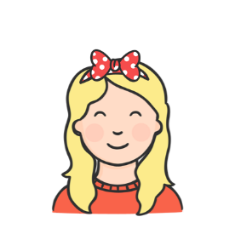
Here is a rough timetable for each day. We cannot wait to see what you all get up to. Please send us photographs on Evidence Me!

If our timetable doesn’t work for you, click below to make your own below:
 | Monday | Tuesday | Wednesday | Thursday | Friday
9.00 – 9.30am
9.30- 10.00am
10.00 – 10.30am
10.30 – 11.30am
11.30 – 12.00pm
12.00 – 1.00pm
1.00 – 2.00 pm
2.00-3.00 pm

